**Virtual Keys**

Virtual Keys is an application that lets users manipulate their file system through an Interface.

It lets the users add, create, delete, search files in the system.

**PURPOSE**

The purpose of this software is to build an online system virtual keys that let users create files in the system. The user can add, delete, search, and sort the files.

**INTENDED AUDIENCE**

The project is a prototype of the proposed virtual keys project and is intended to users who manage the application.

**PROJECT SCOPE**

The purpose of this project, Virtual Key is to ease file creation and handling for the users. We hope to provide a greater user experience in handling various files and directories in the system.

**OVERALL DESCRIPTION**

The Virtual Keys consists of:

User Interactive Screen

The screens lets the user choose the various options in file handling.

File Information

The file consists of user defined objects containing user specified name and data.

The user performs various operations like creating, editing, sorting using file.

Directory

The directory serves as a container for various user defined files and other directories. It stores information like list of files and other directories.

**User NEEDS**

The various user needs are:

1. The user needs an interactive user interface the allows various operations.
2. The user needs to create a file entity from the user interface with an user defined name.
3. The user needs to create directories and add various user defined files in them.
4. The user needs to view the files in ascending order through the interface.
5. The user also needs to search for a specific file within the directory.
6. The user also needs delete a user specified file.

**Assumption and Dependencies**

The various assumptions are:

1. The root directory is already created by default in the application
2. The root directory already contains two files and directories.
3. The data is not stored in the database for the prototype project and data will not be retained on closing the application.

**Flow Chart**

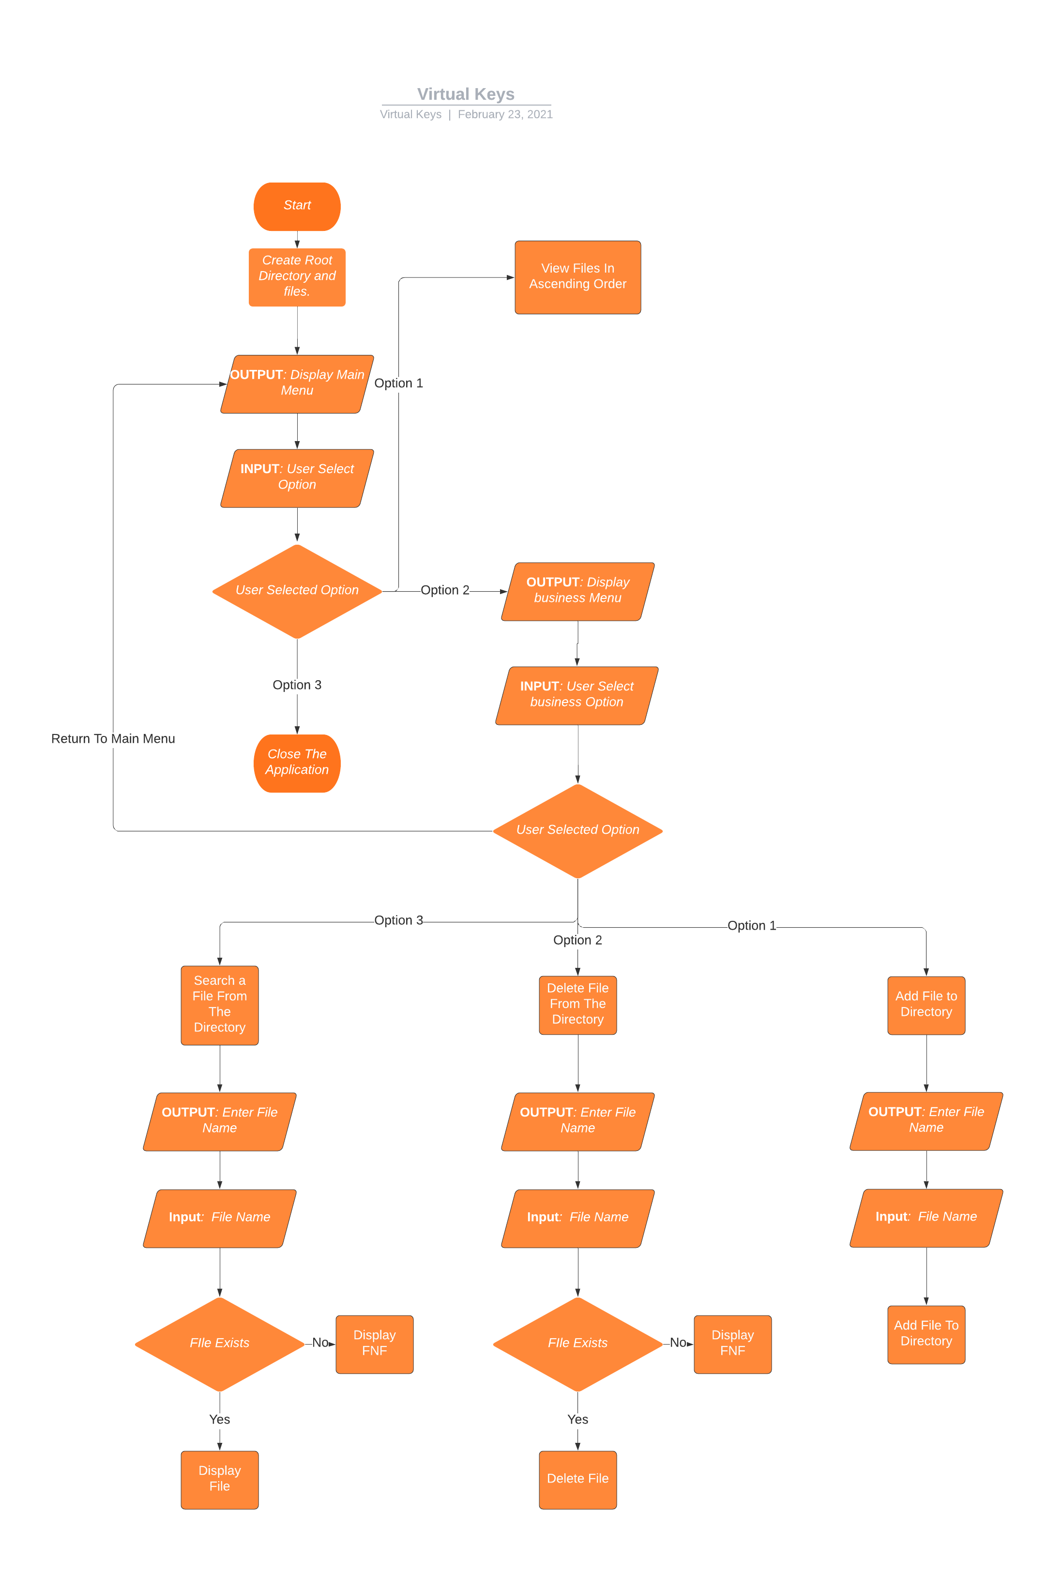

**ALGORITHM**

Step 1: Start

Step 2: Create initial Root Directories and Files.

Step 3: Display Main Menu

Step 4: Read User Input

Step 5: IF User Input = 1

Step 5.1: Sort Files

Step 5.2: Go to Step 3

Step 6: Else If User Input = 2

Step 6.1: Display Business Options.

Step 6.2: Read User Input.

Step 6.3: If User Input = 1

Step 6.3.1: Print “Enter File Name”

Step 6.3.2: Read File Name from User

Step 6.3.3: Add File to Directory

Step 6.3.4: Go to Step 6.1

Step 6.4: If User Input = 2

Step 6.4.1: Print “Enter File Name”

Step 6.4.2: Read File Name from User

Step 6.4.3: If File Exists

Step 6.4.3.1: Delete File

Step 6.4.4: Else

Step 6.4.4.1: Show Error Message

Step 6.4.5: Go to Step 6.1

Step 6.5: If User Input = 3

Step 6.5.1: Print “Enter File Name”

Step 6.5.2: Read File Name from User

Step 6.5.3: If File Exists

Step 6.5.3.1: Print File Exists.

Step 6.5.4: Else

Step 6.5.4.1: Show Error Message

Step 6.5.5: Go to Step 6.1

Step 7: Else if User Input = 3

Step 7.1: Display Thanking Message

Step 8: Stop

**Core Concepts Used**

The core concepts used in this project are:

* Object Oriented Programming
* Core Java Concepts
* Sorting and Searching Concepts
* Java Streams
* Predicates
* Collections
* Exception Handling etc...

**SPRINTS**

SPRINT BACKLOG

|  |  |  |
| --- | --- | --- |
| Day | Tasks | Assignee |
| Not Assigned | Define User Story on Creating Root Directories and Files | Sprint Backlog |
| Not Assigned | Define User Story on Displaying Main Menu | Sprint Backlog |
| Not Assigned | Define User Story on Displaying Files in Ascending Order | Sprint Backlog |
| Not Assigned | Define User Story on Displaying Business Sub Menu | Sprint Backlog |
| Not Assigned | Define User Story on Adding File to the Directory | Sprint Backlog |
| Not Assigned | Define User Story on Deleting File to the Directory | Sprint Backlog |
| Not Assigned | Define User Story on Searching for a File in the Directory | Sprint Backlog |
| Not Assigned | Define the User Story to close the application. | Sprint Backlog |

**WEEK 1**

After discussing with the Business Analysts and Team leads, we have decided to take the following tasks in week 1 sprint.

|  |  |  |
| --- | --- | --- |
| Day | Story | Assignee |
| Day 1 | Define User Story on Creating Root Directories and Files | Tobin |
| Day 2 | Define User Story on Displaying Main Menu | Tobin |
| Day 3 | Define User Story on Displaying Files in Ascending Order | Tobin |
| Day 4 | Define User Story on Displaying Business Sub Menu | Tobin |
| Day 5 | Define User Story on Adding File to the Directory | Tobin |
| Day 6 | Define User Story on Deleting File in the Directory | Tobin |
| Day 7 | Define User Story on Searching for a File in the Directory | Tobin |
| Day 8 | Define the User Story to close the application. | Tobin |

The user stories identified are as follows:

**USER STORIES**

1. Creating Root Directories and Files

As a user when I start the application the root Directory and initial files and Directories be created. If I decide to view the files and folders, I should be able to see the initially created files and directories. The initial files should be named file1, file2 and directories Directory1 and Directory2.

2. Displaying Main Menu

As a User when I start the application, I should be able to see the welcome screen and Main Menus. The Main Menu should be as follows:

1. View Files in Ascending Order.
2. Business Operations
3. Close the Application.

If I select an option it should lead me to the corresponding operation and on entry of invalid option, it should display appropriate messages and show me the Main Menu again.

3. Displaying Files in Ascending Order

As a user when I select the first option from the Main Menu, It should display all the files and directories in the main directory in ascending order.

4. Displaying Business Sub Menu

As a User when I select the second option from the main menu, I should be able to see the Business sub-Menus. The Business sub-Menu should be as follows:

1. Add File to the Directory.
2. Delete File from the Directory.
3. Search a File in the Directory.
4. Return to Main Menu

If I select an option it should lead me to the corresponding operation and on entry of invalid option, it should display appropriate messages and show me the Business sub-Menu again.

5. Adding File to the Directory

As a user when I select this option. The program should prompt me with a text to enter file name. Once entered the application should create a new file with the user entered username. The file should be visible if I go back to main menu and select the option to view files in ascending order.

6. Deleting File in the Directory

On selecting this option. The program should prompt me with a text to enter file name. Once entered the application should search for the file in the directory and if present should delete it from the directory. The deleted file should be displayed if I select the option to view files from the main menu. If the user entered file is not found then show appropriate messages and redirect user to the Sub Business Menu.

7. Searching for a File in the Directory

On selecting this option. The program should prompt me with a text to enter file name. Once entered the application should search for the file in the directory and if present should display that the file was found in the directory. If the user entered file is not found then show appropriate messages and redirect user to the Sub Business Menu.

8. Close the Application.

On selecting the third option from the Main Menu, the user should be shown the appropriate closing messages and the application should terminate.

**After week 1 Status**

|  |  |  |  |
| --- | --- | --- | --- |
| Day | Story | Assignee | Status |
| Day 1 | Define User Story on Creating Root Directories and Files | Tobin | Complete |
| Day 2 | Define User Story on Displaying Main Menu | Tobin | Complete |
| Day 3 | Define User Story on Displaying Files in Ascending Order | Tobin | Complete |
| Day 4 | Define User Story on Displaying Business Sub Menu | Tobin | Complete |
| Day 5 | Define User Story on Adding File to the Directory | Tobin | Complete |
| Day 6 | Define User Story on Deleting File in the Directory | Tobin | Complete |
| Day 7 | Define User Story on Searching for a File in the Directory | Tobin | Complete |
| Day 8 | Define the User Story to close the application. | Tobin | Complete |

The user stories were presented with team leads and other stake holders(Day 6 to Day 10) and were decided to be developed in the next two sprints.

**SPRINT 2**

The above user stories were broken down to tasks for the developer to develop.

The tasks are:

|  |  |  |  |
| --- | --- | --- | --- |
| Day | Story | Task | Assignee |
| Day 11 | Define User Story on Creating Root Directories and Files | Setup the development environments initialize the project. | Tobin |
| Day 12 |  | Develop the features for adding root folder and files | Tobin |
| Day 13 |  | Testing of adding root folder and files | Tobin |
| Day 14 | Define User Story on Displaying Main Menu | Develop the UI for the main menu and code implementation | Tobin |
| Day 15 |  | Testing of Main Menu Features | Tobin |
| Day 16 | Define User Story on Displaying Files in Ascending Order | Develop the features for displaying files and folders in Ascending order | Tobin |
| Day 17 |  | Testing of sorting feature | Tobin |
| Day 18 | Define User Story on Displaying Business Sub Menu | Develop and Designing the features for displaying Sub Menu | Tobin |
|  |  | Testing of Sub-Menu | Tobin |

On day 19 and 20 in Sprint 2 the user task were reviewed and checked if they met Acceptance Criteria. The last user story did not meet the requirements hence was moved to next sprint.

On day 20 the retrospective of the sprint was held and various issues and concerns were discussed. It was found that the last task couldn’t be completed to an issue in the UI design provided.

After Sprint 2, The status is as follows:

|  |  |  |  |  |
| --- | --- | --- | --- | --- |
| **Day** | **Story** | **Task** | **Assignee** | **Status** |
| Day 11 | Define User Story on Creating Root Directories and Files | Setup the development environments initialize the project. | Tobin | Completed |
| Day 12 |  | Develop the features for adding root folder and files | Tobin | Completed |
| Day 13 |  | Testing of adding root folder and files |  | Completed |
| Day 14 | Define User Story on Displaying Main Menu | Develop the UI for the main menu and code implementation | Tobin | Completed |
| Day 15 |  | Testing of Main Menu Features | Tobin | Completed |
| Day 16 | Define User Story on Displaying Files in Ascending Order | Develop the features for displaying files and folders in Ascending order | Tobin | Completed |
| Day 17 |  | Testing of sorting feature | Tobin | Completed |
| Day 18 | Define User Story on Displaying Business Sub Menu | Develop and Designing the features for displaying Sub Menu | Tobin | Not Completed. Moved to next sprint |
|  |  | Testing of Sub-Menu | Tobin | Not Completed. Moved to next sprint |

**SPRINT 3**

The user stories were broken down to tasks for the developer to develop.

The tasks are:

|  |  |  |  |
| --- | --- | --- | --- |
| Day | Story | Task | Assignee |
| Day 21 | Define User Story on Displaying Business Sub Menu (Carry Forwarded from sprint 2) | Develop and Designing the features for displaying Sub Menu . | Tobin |
| Day 22 |  | Testing of Sub-Menu | Tobin |
| Day 23 | Define User Story on Adding File to the Directory | Develop and Designing the features of adding file to the Directory | Tobin |
|  |  | Testing of adding file to the Directory | Tobin |
| Day 24 | Define User Story on Deleting File in the Directory | Develop and Designing the features of deleting file in the Directory | Tobin |
| Day 25 |  | Testing of deleting file in the Directory | Tobin |
| Day 26 | Define User Story on Searching for a File in the Directory | Develop and Designing the features of Searching file in the Directory | Tobin |
| Day 27 |  | Testing of Searching file in the Directory | Tobin |
| Day 28 | Define the User Story to close the application. | Develop and Designing the features of termination screen | Tobin |
|  |  | Testing of termination of the application | Tobin |

On day 29 and 30 in Sprint 3 the user tasks were reviewed and checked if they met Acceptance Criteria. The retrospective meeting was held, and it was noted that all tasks were completed on time. After sprint 3 the status was:

|  |  |  |  |  |
| --- | --- | --- | --- | --- |
| Day | Story | Task | Assignee | Status |
| Day 21 | Define User Story on Displaying Business Sub Menu(Carry Forwarded) | Develop and Designing the features for displaying Sub Menu . | Tobin | Completed |
| Day 22 |  | Testing of Sub-Menu | Tobin | Completed |
| Day 23 | Define User Story on Adding File to the Directory | Develop and Designing the features of adding file to the Directory | Tobin | Completed |
|  |  | Testing of adding file to the Directory | Tobin | Completed |
| Day 24 | Define User Story on Deleting File in the Directory | Develop and Designing the features of deleting file in the Directory | Tobin | Completed |
| Day 25 |  | Testing of deleting file in the Directory | Tobin | Completed |
| Day 26 | Define User Story on Searching for a File in the Directory | Develop and Designing the features of Searching file in the Directory | Tobin | Completed |
| Day 27 |  | Testing of Searching file in the Directory | Tobin | Completed |
| Day 28 | Define the User Story to close the application. | Develop and Designing the features of termination screen | Tobin | Completed |
|  |  | Testing of termination of the application | Tobin | Completed |

Thus after 3 intense sprints of agile methodology the prototype of the application was developed successfully.

**Conclusion**

Virtual keys is a great application that lets users manage their file system through a nice and user friendly interface. Only the prototype of the application is developed, and the real application will have more features and would be more robust. The concept of Streams is widely used in this prototype that enhances code maintainability and readability. It would also help in debugging the code with minimum effort if so, the case rises.

**Screenshots**

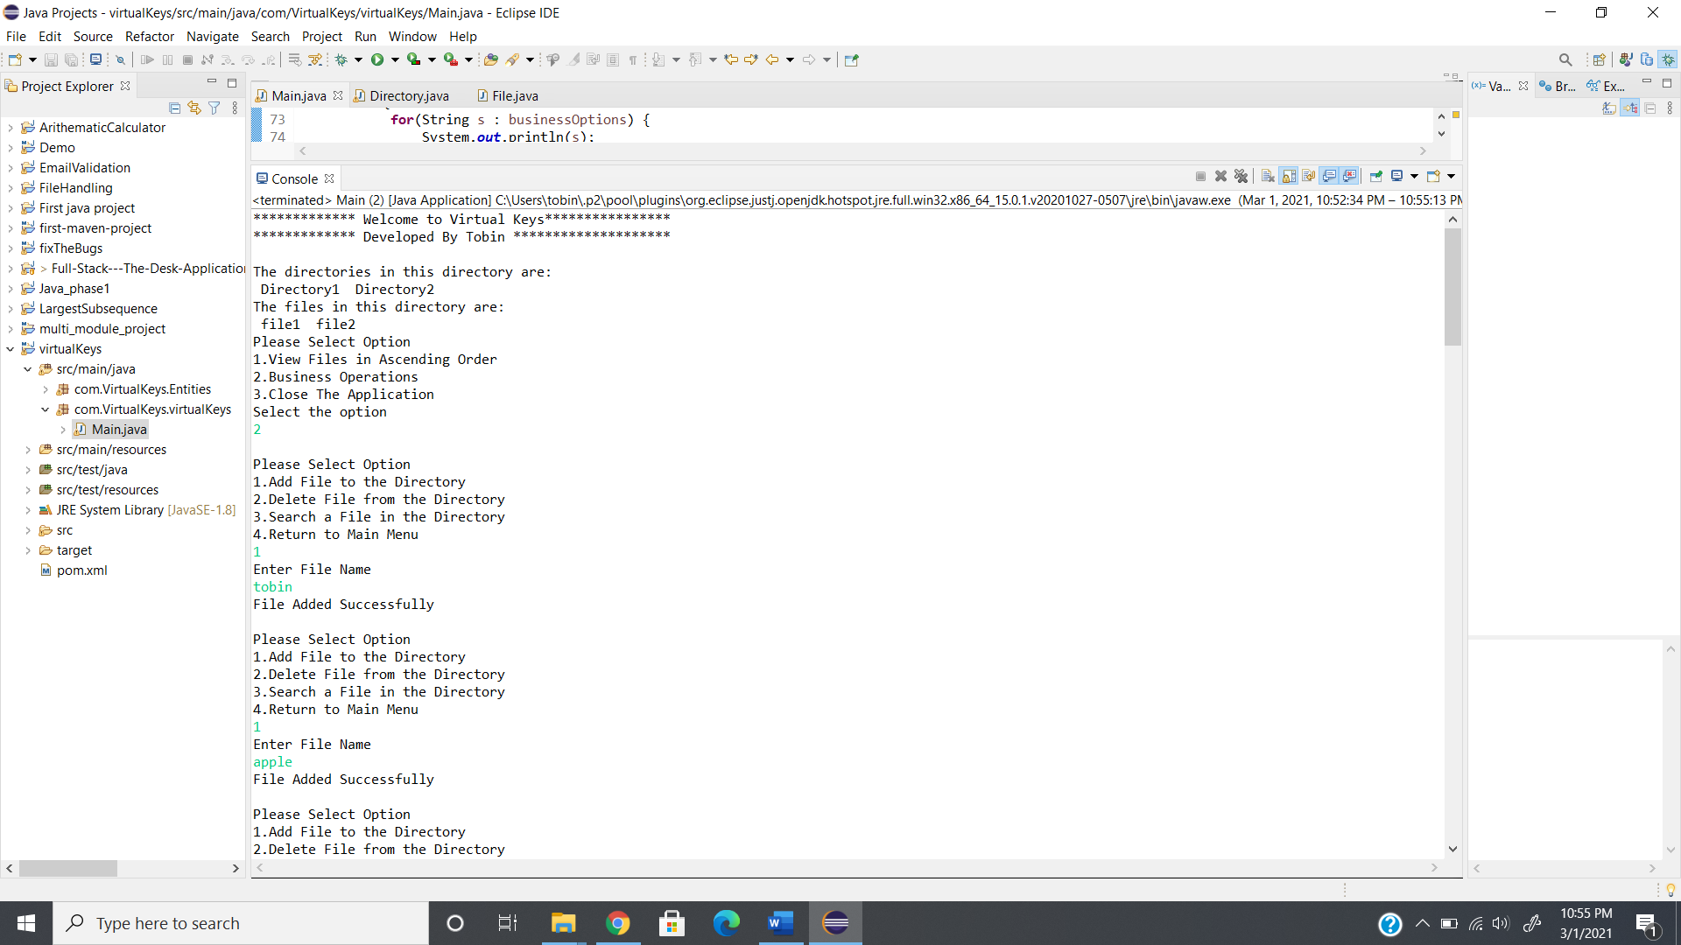

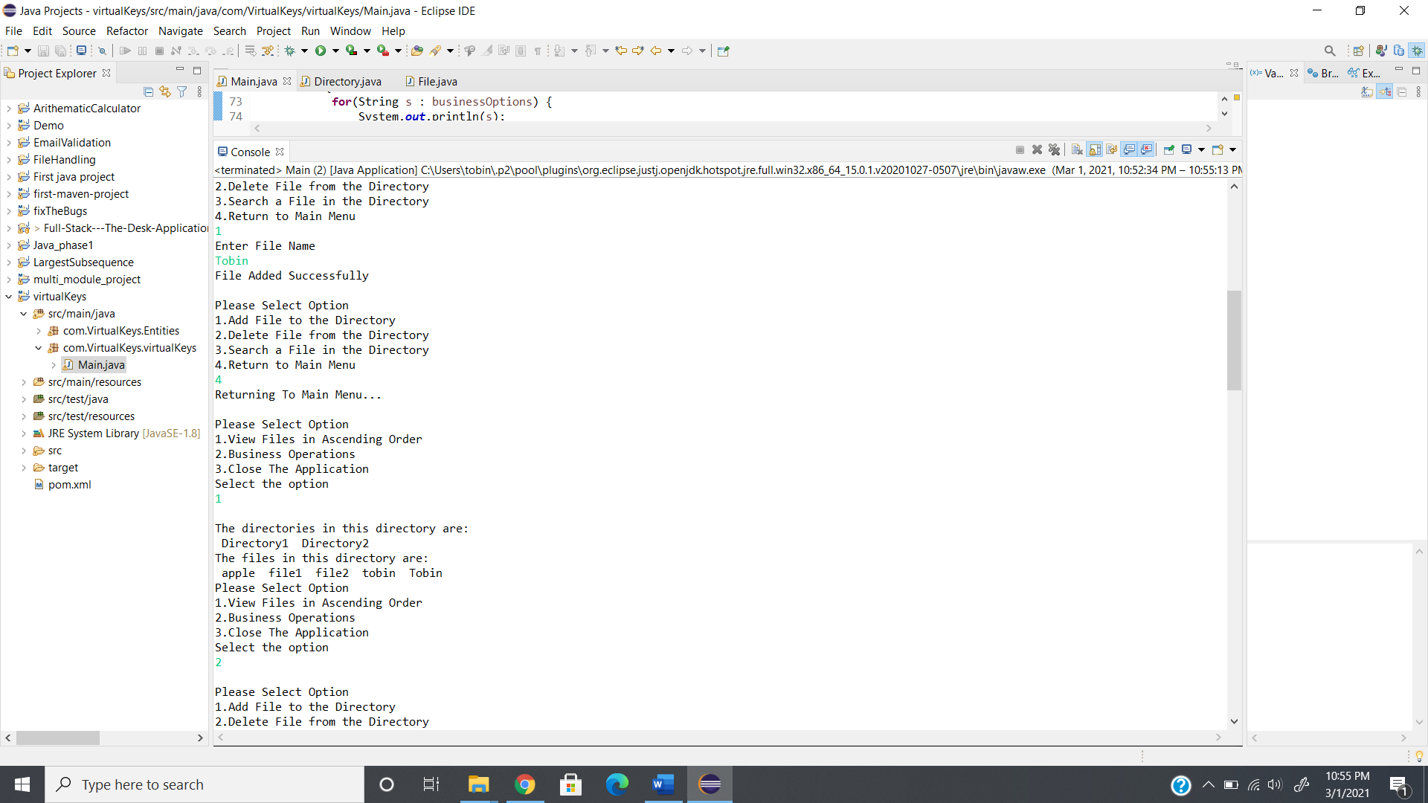

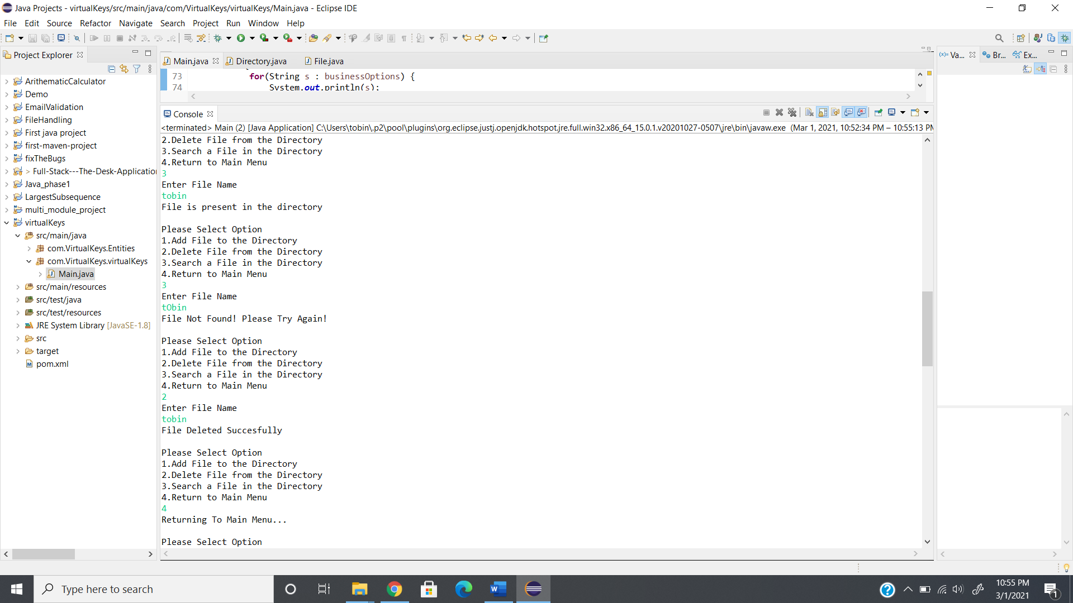

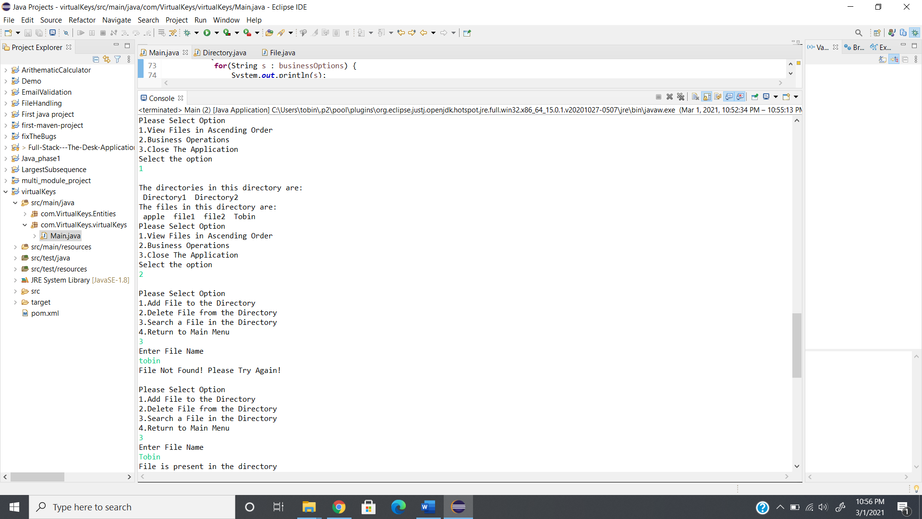

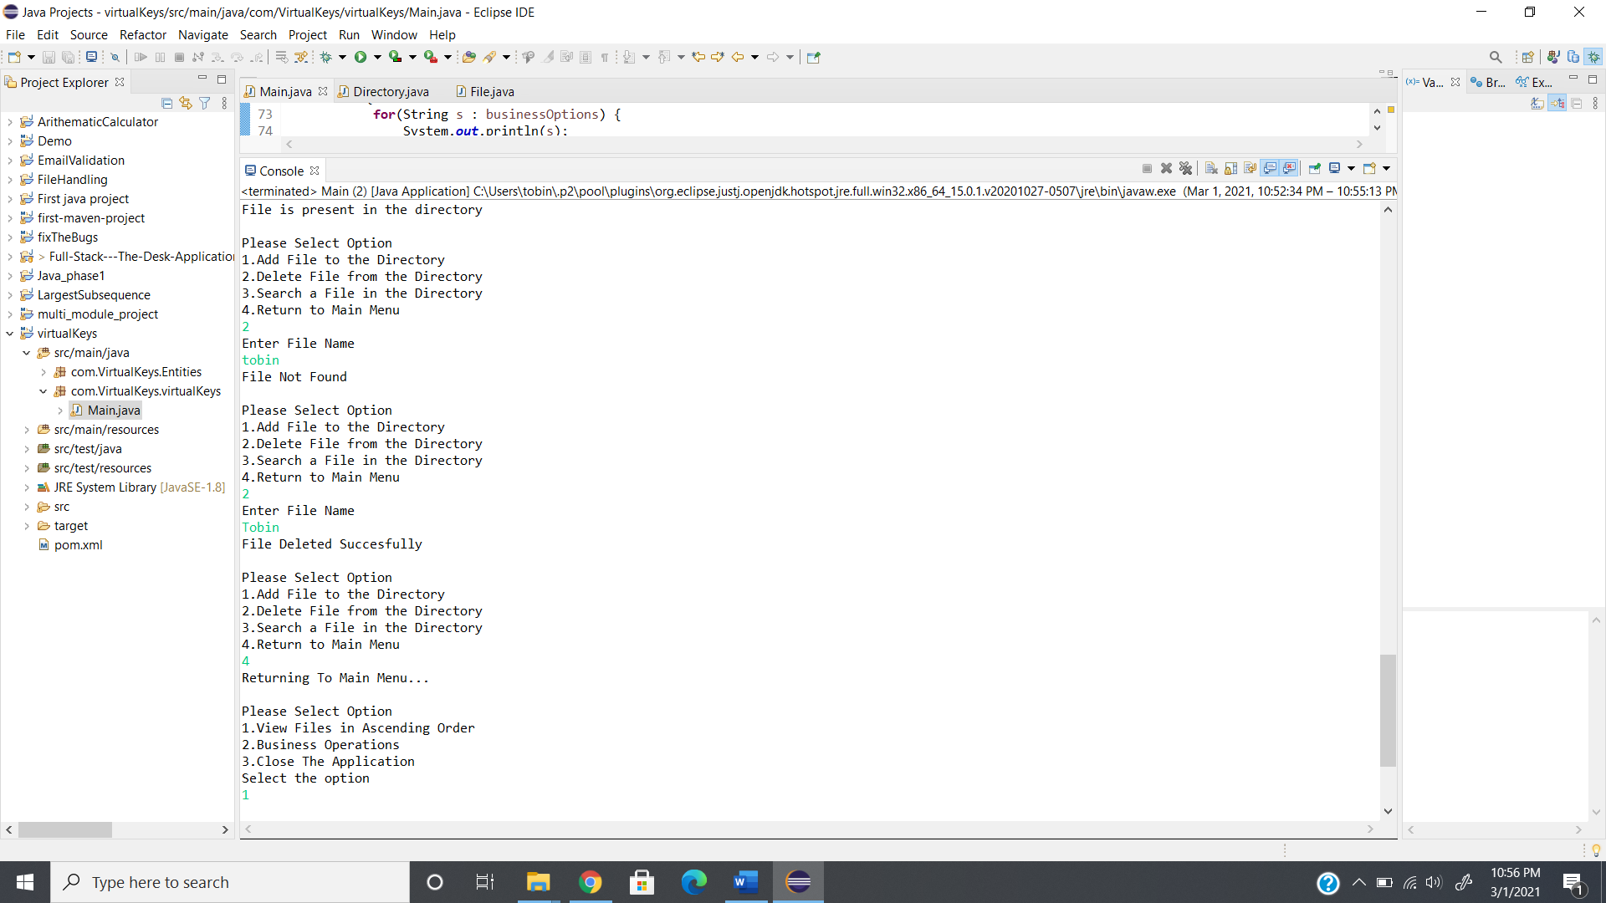

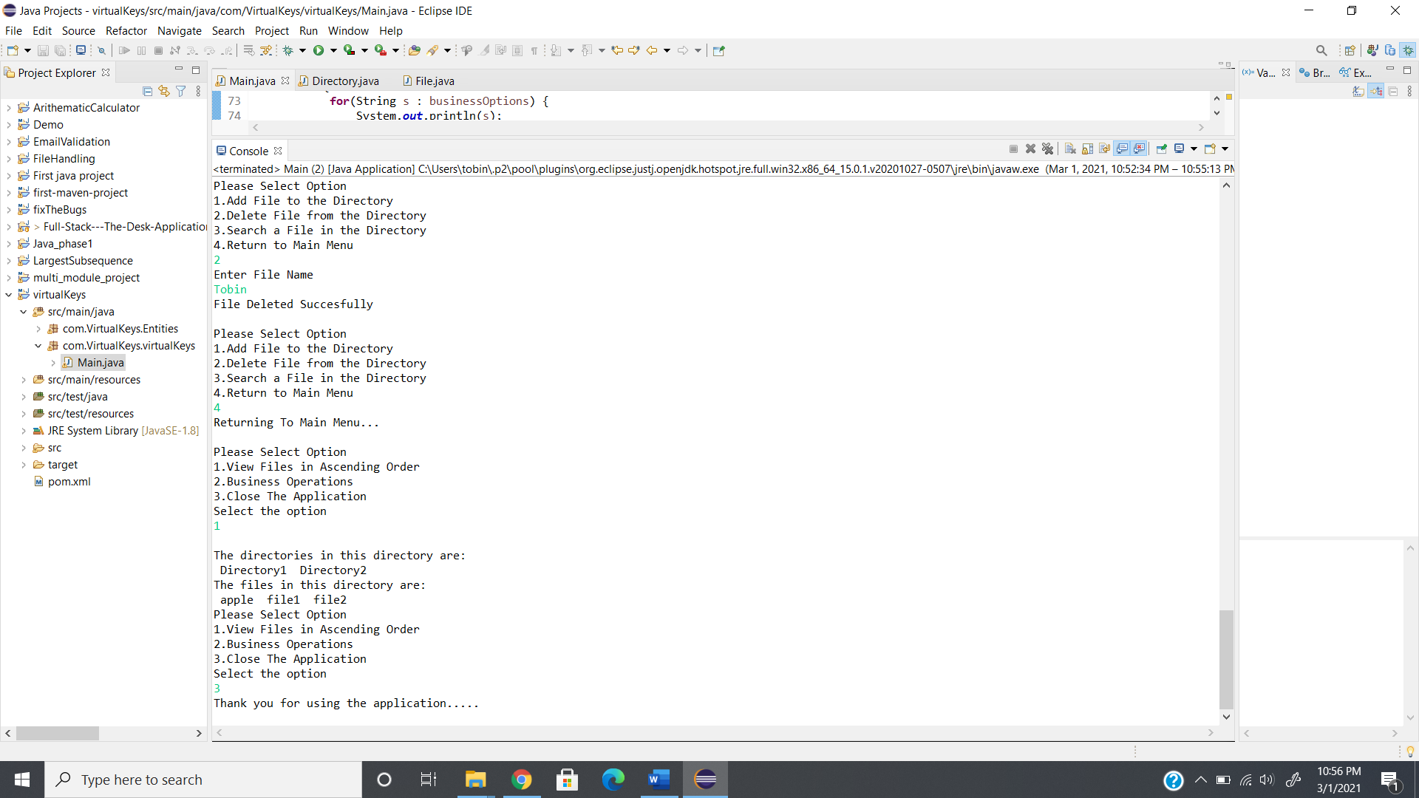

**GitHub Link:**

https://github.com/tobinsajiantony/Java_fsd_Phase_1_VirtualKeys